**Use of smoking substances amongst college students**

By

Mujeeb Ali & Daniel Piri

Advised by Professor Pang

Probability and Statistics Report

Monmouth University

**December 2022**

**Table of Contents**

Abstract

Reason for choosing this topic.

Smoking substances and their effects

Statistical Claims

Survey Structure

Survey Questions

Survey Process

Statistical Overview

Graphs

Analysis

Testing Claims

References

# Abstract

Marijuana and tobacco substances can now be smoked through portable technologies like vape pens, hookah, and electronic cigarettes. Although these new devices pose an even greater health risk amongst their users. There are many speculations about how the creation of portable smoking devices actually minimizes lung-related health issues however there hasn’t been any solid evidence that supports these claims. On the flip side, the majority of people who develop lung cancer are known to have been smokers prior to their diagnosis. The battle between smokers over health risks doesn’t necessarily consist of how a substance is being smoked but rather what substance is used. People who smoke marijuana using different devices often state that tobacco smokers are at a higher risk of developing lung cancer than them. However, they often overlook the general effect of smoking as a whole. The survey serves as a real-life analysis of people's experience with smoking or smokers and what they deem to be most at risk for developing lung cancer.

# Reason for choosing this topic

Smoking in general is very popular amongst college students, however, there is a constant push and pull over the potential side effects of smoking tobacco or marijuana and how marijuana is much safer to smoke than tobacco. Oftentimes, students argue that there hasn’t been any proven case of marijuana causing lung cancer in comparison to tobacco, as a result, many continue to smoke marijuana and other products that don’t specifically contain tobacco but rather its stimulant nicotine. However, I don’t think many college students are aware of the potential health risks of smoking in general. The burning of any chemical or substance being inhaled for long periods of time is more than likely to do more harm than good. Also, the types of paper used to smoke marijuana contain tobacco, and the types of chemicals used to smoke nicotine sticks and vape pens when burned can be harmful. With the reputation of college and temporary fun it is associated with, many college students overindulge in these practices unaware of the potential health risks that come with it 10-15 years down the line. My approach for this topic is to take an statistical approach to see exactly how many people smoke in general and if they care about the potential health risks associated with it.

# Smoking substances and their effects

**Tobacco:** The known effects of smoking tobacco are heart disease, stroke, lung cancer, and chronic bronchitis.

**Marijuana:** The known effects of smoking marijuana are altered senses, changes in mood, impaired movement and memory, delusions, psychosis, and hallucinations

**Nicotine sticks/Vape Pens/E-cigarettes:** The known effects of smoking these substances are exposed to harmful chemicals, chronic lung disease, asthma, heart disease, lung scarring, EVALI, and organ damage **Claims**

# Claim #1: Students below the age of 21 are more likely to smoke marijuana than cigarettes and vapes(Ndegwa,Stephen,Alice,Oladipo)

By law, anyone at or over the age of 21 is allowed to purchase, carry and use marijuana, cigarettes, and vapes. However, the use of marijuana is only legal in 21 states nationwide with New Jersey being one of the states that have also legalized its use. When looking at things on a smaller spectrum, many people begin to indulge in marijuana before they turn 21. Although illegal, a 2019 “American Academy of Child & Adolescent Psychiatry” article states that teenage/young adult marijuana use is at its highest level in 30 years. Prompting that today’s teens are more likely to use marijuana than tobacco. On the health side of things, medical professionals have also studied that marijuana use before the age of 18 is associated with future dependence and abuse. However, the use of cigarettes isn’t as prominent as marijuana. Studies show a decrease in the percentage of young adults between the ages of 18-24 who smoked cigarettes from 2011(18.9%) to 2017(10.4%). Also, the use of cigarettes and other tobacco products has been directly linked to lung cancer and other forms of cancer in comparison to marijuana and vape products. Vape products are heavy contenders to recreational marijuana use given their easy access and simplified mechanical use however many of these products don’t give users the same stimulation as other smoking substances so they usually end up being the latter of the three.

# Claim #2: 44% of college students smoke marijuana on a daily basis(Parker)

With the legal age being 21 in most states in America, many college students indulge in the recreational use of marijuana. Given the academic stress the majority of college students face year-round, some use marijuana to cope. However, marijuana use on college campuses is quite common for other various reasons. Some use marijuana during their free time just to let time fly by, others use marijuana for medical purposes only and some may even use marijuana to help with their studies. However, studies have proven that students who smoke marijuana frequently tend to have lower GPAs than students who don’t and they are more likely to skip class and extend the time it takes them to graduate. **Claim #3: On average the amount of men who smoke, in general, is greater than the amount of women(Ho)**

When looking at things on a larger scale there are approximately 7.8 billion people in the world with 3.97 billion being males and 3.9 billion being females. Based on these numbers one would think the number of smokers between men and women will be around the same number however the difference varies at a high percentage. Studies show that men are 5 times more likely to smoke than women. Everyone out of three men smokes and every one out of sixteen women smoke. That’s a 27 percent difference between men and women. Although, the reasons associated with each sex differ. In unison, both parties smoke to cope with stress and negative moods however there are more health risks associated with women smoking than men. For that same reason, women are less likely to indulge in smoking for fear of developing cancers such as breast cancer, ovarian cancer, and also lung cancer. The same pertains to men however breast cancer isn’t as common for men, and lung cancer is more associated with smoking habits.

**Claim #4: The average college student spends 20 dollars a week on smoking substances(Nichter)** A cost helper article states that the average cost of marijuana is 20 dollars. The average cost of cigarettes is 8 dollars and the average cost of vape pens is 15 dollars. Also the average cost for smoking marijuana varies how much you smoke during the week but it could definitely be 10-30 dollars a week. Every student's prices may vary but this is the average. Some might be spending double or triple depending how much they actually smoke a week. Also some might not even smoke close to that amount a week because they only smoke once a week and very little quantity. Vapes typically can last you a very long time if you don't use it often but if you use it daily and multiple times a week it can definitely rack up price wise for the college student. Same goes with cigarettes and marjuana it really just depends how much you smoke a week and if it's multiple times a day. Typically cigarettes you smoke more than one a day so if that's the case you're probably smoking it every day especially because it's very addictive which increases the amount you spend weekly. Cigarettes can also be the most expensive on this list if you're addicted to them because a pack of cigarettes comes with 20 and it's about 8-10 dollars a pack. Smoking can overall be very expensive if you do it very often and don't have any control of stopping but could also be very cheap if it's not a daily thing you do and more like once a week.

**Claim #5: On average 70% of college students don’t smoke any type of substance(Steptoe)** College students range from typically 18-24 years old and that is 3/5 of the population of college students which comes out to 12.3 million students. Many students who don’t want to smoke in college and want to focus on their education actually do the same research as their parents to find a school with a low smoking percentage and also smoke-vape free living headquarters. Students who live in a lower income home typically have a higher smoking percentage compared to a student who is financially stable. Main reason for smoking in college is for people to socialize but also to fit into certain groups there are also for parties and stress reasons. 65 percent of college students don't smoke and that number is not good. That means 35 percent smoke. Colleges are making it more common to make campus smoke free because the number is high but also they know it's not good for the students. Smoking can cause long-term effects no matter how much or how often you smoke. Making the numbers go down will continue if the campus can restrict stronger punishments for students being caught.

**Claim #6: 6.6% of male smokers are likely to develop lung cancer than nonsmokers(Crispo)** Students who smoke typically don’t care about the consequences at the moment but later down the road if they get sick or something and they have a bad experience from it could make them consider if it's bad for their health. People who dont smoke often very rarely care about the consequences that could happen but enjoy doing it once in a blue moon for the feeling. Whatever you smoke will give you a certain type of feeling depending on what is smoked. College students usually are young 18-24 and don't think that it's possible to get any type of sickness from it or have anything happen to them because they feel invincible. Later they find out it paid a toll on their health for being unhealthy and smoking multiple times a day and also multiple times a week. Anything you smoke is bad for you and can cause long-term effects. So the best alternative is not to smoke anything if you want to be healthy and live and long as possible

**Claim #7: 5.8% of female smokers are likely to develop lung cancer than nonsmokers(Nakhaee)** The societal norm of men being heavy smokers in comparison to women remains dominant in today's society still. When looking at different forms of media such as smoking advertisements, social media advertisements and even some movies, most of the time the person smoking is usually male. The claim was chosen to have a statistical look at why the percentage of male and female smokers differ in the likelihood of getting lung cancer. Smoking in general is known to have harmful side effects however when taking a deeper look, lifestyle choices by male and female can differ greatly which can also make an impact on their smoking habits.

# Claim #8: 45% of college students smoke to relieve stress(Levinson)

A lot of students who come to college have never smoked a day in their life but when they set foot on campus all of a sudden they become frequent smokers. Why is that? A question that stuck out to us. Well when taking a step back, a student coming into college deems an increase in responsibilities. Many students are given freedom that they’ve never had as a result of being away from their parents, at the same time many students are also exposed to new temptations when coming into college. In addition to the headaches of school and maybe extracurriculars. The accumulation of all these factors can weigh down heavily on the everyday college student which can then be detrimental to the students everyday life. Hence, students then seek for forms of outlets to find ways to cope with their hectic lifestyles. Smoking, a commonly known coping habit, is most frequently adopted amongst college students as a way of cooling down and getting right back to ground zero.

# Claim#9: Students above the age of 21 are more likely to smoke marijuana than cigarettes and vapes (No source, response research)

In relation to our first claim, we were looking at students above the age of 21 that smoke marijuana over smoking substances; however, in this claim we are flipping the script and looking at students above the age of 21 that smoke marijuana. We chose this claim to get an even look on both sides of the spectrum. Once you can see the hypothesis on both ends of a claim it is easier to make a final hypothesis on the overall topic at hand. This directly correlates to our topic also thus making this claim highly beneficial to our statistical report.

# Data Collection Survey Structure

The structure of the survey is designed to get the most information that we could possibly get. The first two questions are used to determine the gender and the age group that is important for our results. We made sure when doing the survey to get important information regarding what these students smoke, how often they would be smoking a week, and also how much they spend a week smoking. The last couple of questions are basically trying to figure out if they are worried that there is a possibility of smoking leading to lung cancer and if they want to quit what is stopping them. All of this information will give us information to work with and will allow us to compare our data and online data that was found.

**Survey Questions**

What is your gender?

What is your age?

What do you smoke?

How many days in a week do you smoke? (Tobacco, Cigarettes, Vape, Weed)

If you smoke cigarettes do you smoke a pack a day? ( Answer none if you don't smoke cigarettes)

If you vape do you smoke every day? (Answer no if you don’t smoke vapes)

If you smoke weed do you smoke every day? (Answer no if you don't smoke weed)

If you do any of the following how much do you spend in a week? (Put 0 if you don’t smoke)

If you smoke, do you worry about possible lung cancer in the future? (If you don’t smoke just click no) If you answered yes to the previous questions, what is stopping you from quitting? (If you put no type none)

**Survey Process**

We created our survey using Google Forms and sent it out to students from Monmouth University and other colleges. About 100 were done on google forms and 50+ were done in person.

# Statistical Overview Graphs Descriptions

The graphs below represent the data we found from our survey on the Smoking Substances by college students. The survey was only sent out to college students. This means that Monmouth Students completed the survey as well as students from other colleges and universities.

Figure 1 represents the percentage and values of the amount of students who smoke under 21. Out of 89 responses 20 voted yes to smoking marijuana .This is represented as 22% on the graph. Out of 89 responses 69 voted no. This is represented as 78% on the graph. Out of 151 responses, 62 people didn’t vote. Figure 2 represents the percentage and values of students who smoke marijuana on a day to day basis. 66 out of 151 responses voted yes. This is represented as 44% on the graph. 85 out of 151 voted no. This is represented as 56% on the graph. Everyone voted. Figure 3 represents the percentage and value of male vs female smokers that smoke. When all responses were recorded. The total vote came up to 151. 45 out of 89 males were smokers. This is represented as 50.5 on the graph with a percentage of 47. 39 out of 69 females were smokers. This is represented as 56.5 on the graph with a percentage of 53%. For this graph we wanted to show how women smoked more than men even though the total amount of females was less than the total amount of men. Figure 4 represents a histogram of how much college students spend weekly on smoking substances. The x-axis represents the costs inputted by user responses and the y-axis represents the amount of students that also spend the same amount. 26 students reported spending 0 dollars, 5 reported spending 10 dollars, 1 spent 12 dollars, 2 spent 13 dollars, 2 spent 15 dollars, 12 spent 20 dollars, 1 spent 24 dollars, 7 spent 25 dollars, 14 spent 30 dollars, 3 spent 35 dollars, 5 spent 40 dollars and 4 spent 50 dollars. The mean of all costs was 26 dollars and 57 cents. Figure 5 represents a histogram of the smoking substances used by college students. The values on the x-axis represent the smoking substances used. The values of the y-axis represent the amount of students that used each substance. 12 students reported smoking cigarettes, 35 students reported smoking weed, 30 students reported smoking vapes, 3 students reported using tobacco products and 36 students reported none. Figure 6 represents the percent of male and female smokers to nonsmokers in general. 39 out of 69 females smoke. This is represented as 26% on the graph. 45 out of 82 males smoke. This is represented as 30% on the graph. 67 out of 151 students are nonsmokers this is represented as 44% on the graph.

**Analysis**

All of our graphs were created in Google Sheets and through Google Forums. We collected the data from our survey on Google Forum and then transferred our data from Google Sheets to an excel file. It was a bit difficult in the beginning since some questions were better displayed as pie charts than histograms so we had to manually create histograms and also pie charts to find the best fit for each claim. I used pie charts to improve understanding and readability of claims that dealt with percentages of populations. I used histograms for claims that covered populations to numerous proportions. Pie charts can be seen in Figure 1, Figure 2, Figure 3 and Figure 6. Histograms can be seen in Figure 4 and Figure 5. The most surprising realization for us was when we saw how women actually smoked more than men even though the total population of men in addition to the total population of men that smoked was greater than both female smoking population and also female population in total. Which meant that at Monmouth University, women smoke more often than men.

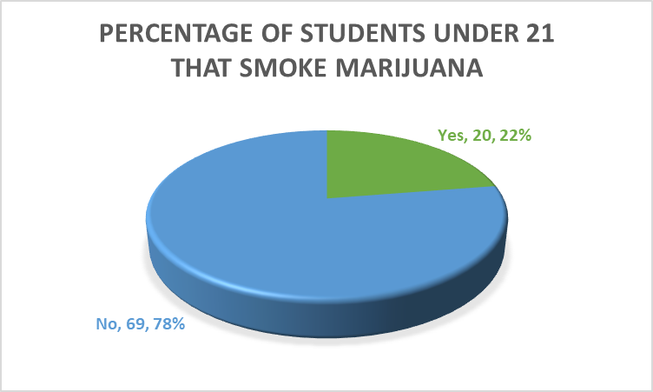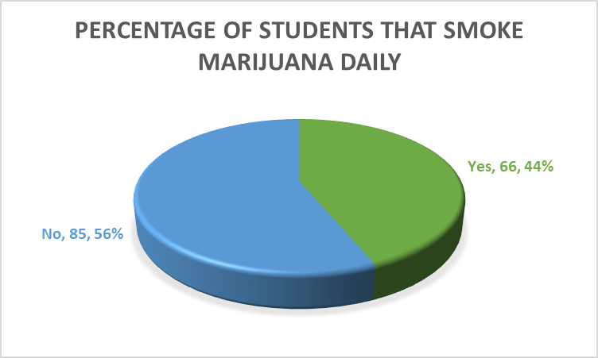

# Figure 1 Figure 2

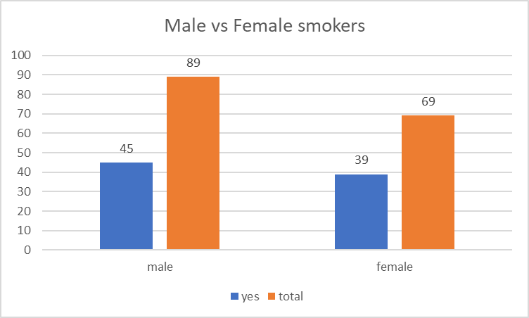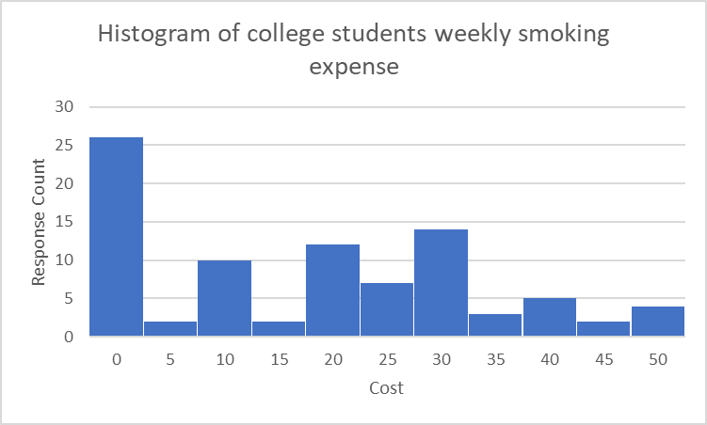

# Figure 3 Figure 4

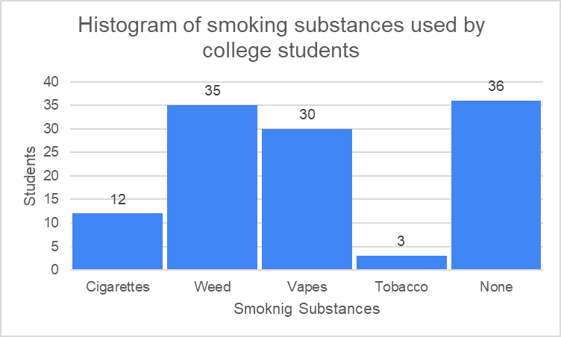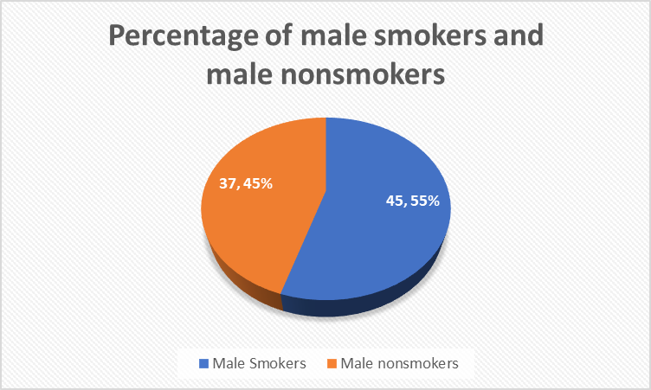

# Figure 5 Figure 6

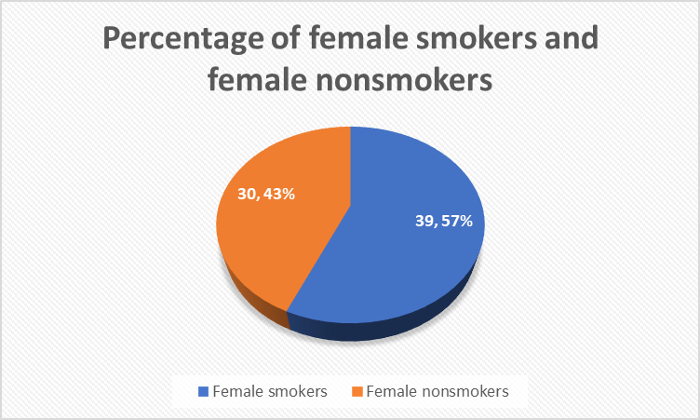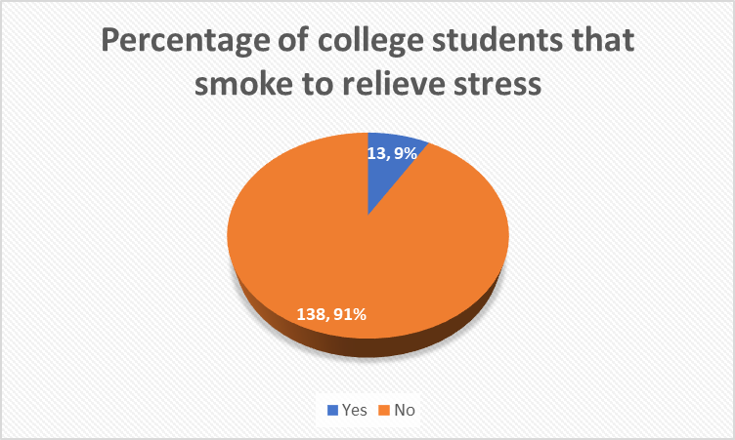

# Figure 7 Figure 8

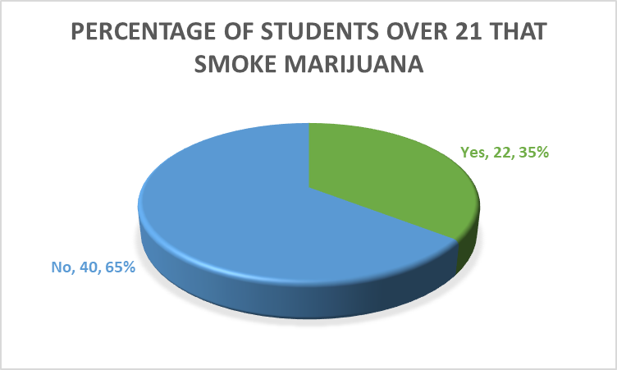

**Figure 9**

**Testing Claims:**

# Claim 1:Students below the age of 21 are more likely to smoke marijuana than cigarettes and vapes

Claim PWeed&Under21>0.5 Ho: PWeed≤0.5 H1:PWeed>0.5

We believe this claim is true because students that attend college under the age of 21 have a less than a 50 percent chance of smoking weed. Amongst the data samples we recorded, we have calculated that 20 out of 89 students who are the age under 21 smoke weed. For more accurate results we are testing that this claim will be true that students under 21 that smoke weed are less than 50 percent of the sample being tested. RStudio library(mosaic) prop.test(x=20, n=89, p=.5, alternative = "greater",correct=FALSE)

1-sample proportions test without Summary:

Continuity correction Voted yes: 20

Data: 20 out of 89 Voted no: 69

X-squared = 26.978, df = 1, p-value = 1 Total vote: 89

Alternative hypothesis: true p is greater than 0.5 Didn’t vote: 62

95 percent confidence interval; Sample Percentage: 50% Sample estimates: p

0.2247191

When we ran a 1-P test in RStudio, we found out that the percentage of college students under 21 that smoke weed is less than 50 percent. The p-value, 1, is greater than the significance level, 0.05. This means that we fail to reject H0 when P-value =1 > alpha = 0.05. We do not support our initial claim that PWeed&Under21>0.5. Therefore, we can conclude that the percentage of college students under 21 that smoke weed is not the majority.

# Claim 2: 44% of college students smoke marijuana on a daily basis

Claims PStudents smoke weed on daily basis > 0.44 H0 : PStudents smoke weed on daily basis ≤ 0.44 H1 : PStudents smoke weed on daily basis >

0.44

We believe this claim is true because students that attend college have a less than 44 percent chance of smoking marijuana on a daily basis. The percentage would be different if the question asked if people smoked during the week at least once but smoking daily could be very expensive for those reasons that's why the percent is where it's at. Smoking daily could also be very bad for your health which is another reason why the percent could be where its at because people may worry of the consequences it could generate in the future. Smoking daily is considered smoking at least once a day. Our survey we tested to see how many people smoke marjuana daily. Amongst the data samples we collected, we have calculated that 66 out of 151 students smoke marijana on a daily basis. For more accurate results we are testing that this claim will be true that less than 44 percent of students smoking marijana daily.

library(mosaic)

prop.test(x=66, n=151, p=.44, alternative = "greater",correct=FALSE)

1-sample proportions test without

continuity correction Summary:

data: 66 out of 151 Voted yes: 66 X-squared = 0.0052034, df = 1, Voted no: 88 p-value = 0.5288 Total Votes: 151 alternative hypothesis: true p is greater than 0.44 Didn’t vote: 0

95 percent confidence interval: Sample Percentage: 44%

0.3723749 1.0000000 sample estimates:

p

0.4370861

When we ran a 1-P Test in RStudio, we found that more students in our data actually smoke marijuana daily more than what we found in the research by 15 percent. The P-value, 0.5288 is much greater than the significance level, 0.05. This means that we fail to reject Ho when P-value = 0.5288> alpha = 0.05. We do not support our initial claim that PStudents smoke weed on a daily basis > 0.44.

# Claim 3: On average the amount of men who smoke, in general, is greater than the amount of women

Claim PMale > PFemale H0: PMale ≤ PFemale H1: PMale > PFemale

We believe this claim is true that men smoke more than women in general. There are plenty of factors why males could be smoking more than women. Amongst the data samples we collected, we have calculated that 45 out of 82 males smoke and 39 out of 69 women smoke. For a more accurate result, we are testing to see if our claim is true that more men smoke than women do in general to see if our research was correct. library(mosaic) Summary:

prop.test(x = c (45,39), n = c (82,69), alternative = "greater") # of male smokers:45

2-sample test for equality of # of female smokers:39 proportions without continuity # of non smokers: 67

Correction # of people in total: 151

data: c out of c45 out of 82 39 out of 69 p-value: 0.7717

X-squared = 0.55446, df = 1, p-value = 0.7717 alternative hypothesis: greater 95 percent confidence interval:

-0.1908808 1.0000000 sample estimates:

prop 1 prop 2

0.5056180 0.5652174

When we ran a 2-T test in RStudio, we found out that women actually smoke more in general than men do by 6 percent. The P-value, 0.7717 is much greater than the significance level 0.05. This means we fail to reject Ho when P-value = 0.7717 > alpha = 0.05. We do not support our initial claim that Claim PMale >

PFemale.

# Claim 4: The average college student spends 20 dollars a week on smoking substances

Claim PSmokes > 20 H0: PSmokes ≤ 20 H1: PSmokes > 20

We believe that this claim is true because of how much students are actually spending on smoking substances and that you really can't save money on smoking. The price is typically what is and the students spend the amount for the smoking substance. We believe that if college students could save money somehow on smoking substances they would definitely take the opportunity to do so. Our research when looking at how much do people typically spend on smoking substances a week was 20 dollars. We collect data from our survey seeing how much students are actually spending a week and from that seeing what the mean is. library(TeachingDemos) Summary:

z.test(Claim_4$Costs, alternative ="greater", mu=20, stdev=10.57) Mean: 26.57471

One Sample z-test SD: 10.5700 data: Claim_4$Costs p-value: 3.281e^-09 z = 5.8018, n = 87.0000, Std. Dev. = 10.5700, Std. Dev. of the sample mean = 1.1332, p-value =

3.281e-09 alternative hypothesis: true mean is greater than 20 95 percent confidence interval:

24.71073 Inf sample estimates:

mean of Claim_4$Costs

26.57471

When we ran a 1-Z test in RStudio, we found that students from our data actually spend more on smoking than the average we found in our research. We found that students in our survey are actually spending 6 dollars more than the average from our research. The P-value, 3.21e-09 is much less than the significance level of 0.05. This means that we reject H0 when P-value = 3.21e-09> alpha 0.05. We support our initial Claim that PSmokes > 20.

# Claim 5: On average 70% of college students that don’t smoke any type of substance

Claim PNon-Smokers > 0.7 H0: PNon-Smokers ≤ 0.7 H1: PNon-Smokers > 0.7

We believe this claim is true because students that attend college have a less than 70 percent chance of not smoking any type of smoking substances. The data we collected from our survey will let us know what percent of students don't smoke any type of substances. Amongst the data samples we collected, We have calculated that 62 out of 151 students don't smoke any type of substances. For more accurate results we are testing that this claim will be true that less than 70 percent of students are not smoking any type of substance. library(mosaic)

prop.test(x=62, n=151, p=.7, alternative = "greater",correct=FALSE

1-sample proportions test without

continuity correction Summary

data: 62 out of 151 # of students that don't smoke: 62

X-squared = 60.224, df = 1, # of people in total: 151

p-value = 1 P-value: 1

alternative hypothesis: true p is greater than 0.7 95 percent confidence interval:

0.3468833 1.0000000 sample estimates:

p

0.410596

When we ran a 1-P test in RStudio,we found that less students in our survey smoke than what we had researched which showed the average being about 70 percent of students don't smoke any type of substance. The P-value, 1 is much greater than the significance level, 0.05. This means that we fail to reject H0 when P-value = 1 > alpha = 0.05. We do not support our initial claim that PNon-Smokers > 0.7. **Claim 6: 6.6% of male smokers are likely to develop lung cancer than nonsmokers**

Claim: PMale > PNonSmoker H0: Pmale ≤ PNonSmoker H1: PMale > PNonSmoker

We believe this claim is true that 6.6 percent of male smokers are more likely to develop lung cancer than nonsmokers. Reasons are probably because they are smoking and hurting their lungs by doing so. Amongst the data samples we collected, we have calculated that 45 out of 89 males that smoke and 67 out of 151 are non smokers. For a more accurate result, we are testing to see if our claim is true that 6.6 percent of males smokers are more likely to develop lung cancer than nonsmokers.

library(mosaic)

prop.test(x=c(45, 37), n=c(82,82), alternative = "greater", correct=FALSE)

2-sample test for equality of proportions without continuity correction

data: c out of c 39 out of 69 30 out of 69 Summary

X-squared = 1.561, df = 1, Male smokers: 45 out of 82 p-value = 0.1058 Male Nonsmokers 37 out of 82 alternative hypothesis: greater P-Value: 0.1058

95 percent confidence interval:

-0.03026779 1.00000000 sample estimates:

prop 1 prop 2

0.5487805 0.4512195

When we ran a 2-T test in RStudio, we found the P-value, 0.1058 is much greater than the significance level 0.05. This means we fail to reject the Ho when P-value = 0.1058 > alpha = 0.05. We do not support our initial claim that PMale > PNonSmoker.

# Claim 7: 5.8% of female smokers are likely to develop lung cancer than nonsmokers

Claim: PFemale > PNonSmokers H0: PFemale ≤ PNon-Smoker H1: PFemale > PNon-Smoker

We believe this claim is true that 5.8 percent of female smokers are more likely to develop lung cancer than nonsmokers. Reasons are probably because they are smoking and that affects their lungs which could cause lung cancer. Amongst the data samples we collected, we have calculated that 39 out of 69 females smoke and 67 out of 151 students do not smoke. For a more accurate result, we are testing to see if our claim is true that 5.8 percent of females are more likely to develop lung cancer than nonsmokers. library(mosaic)

prop.test(x=c(39,30), n=c(69,69), alternative = "greater", correct=FALSE)

2-sample test for equality of proportions without continuity Summary

Correction Female smokers: 39 out of 69 data: c out of c 39 out of 69 67 out of 151 Female nonsmokers: 30 out of 69

X-squared = 2.3478, df = 1, P-Value: 0.06273 p-value = 0.06273 alternative hypothesis: greater

95 percent confidence interval:

-0.00838857 1.000000000 sample estimates: prop 1 prop 2

0.5652174 0.4437086

When we ran a 2-T test in RStudio, we found the P-value, 0.06273 is less than the significance level 0.05.

This means we fail to reject Ho when P-value = 0.06273> alpha = 0.05. We don't support our initial claim:

PFemale > PNonSmokers.

# Claim #8: 45% of college students smoke to relieve stress

Claim: PStudents smoke to relieve stress> 0.45 H0:PStudents smoke to relieve stress ≤ 0.45 H1: PStudents smoke to relieve stress > 0.45

We believe this is true because college students typically only smoke for certain reasons. College is a very stressful environment and it could be that way for various reasons like not fitting in or your classes are very hard. So, you would assume that students are smoking for reasons because they are stressed out and want to feel some relief. Our survey we tested to see how many people smoke and for what reasons the most common was for stress. Amongst the data samples we collected, we have calculated that 13 out of 151 students smoke to relieve stress. For more accurate results we are testing that this claim will be true that less than 45 percent of students smoking are doing that to relieve some sort of stress they are having.

1-sample proportions test without continuity correction

data: 13 out of 151 Summary

X-squared = 80.795, df = 1, p-value = 1 Smokers to relieve stress: 13

alternative hypothesis: true p is greater than 0.45 Total people: 151 95 percent confidence interval: P-Value: 1

0.05545701 1.00000000 sample estimates: p

0.08609272

When we ran a 1-P test in Rstudio, we found that our students actually smoke at lower percent than the research we found. The P-value, 1 is much greater than the significance level, 0.05. This means that we fail to reject Ho when P-value = 1 > alpha = 0.05. We do not support our initial claim that PStudents smoke to relieve stress> 0.45.

# Students above the age of 21 are more likely to smoke marijuana than cigarettes and vapes

Claim: Pweed&over21> 0.50 H0:Pweed&over21 ≤ 0.50 H1: Pweed&over21 > 0.50

We believe this is true because students that attend college over the age of 21 have a 50 percent chance of smoking weed. Amongst the data sample we recorded, we have calculated that 22 out of 62 students who are the age of 21 and above smoke weed. For more accurate results we are testing that this claim will be true that students above 21 that smoke weed are less than 50 percent of the sample being tested.

1-sample proportions test without continuity correction data: 22 out of 62

X-squared = 5.2258, df = 1, p-value = 0.9889 Summary alternative hypothesis: true p is greater than 0.5 Voted yes: 22

95 percent confidence interval: Voted no: 40

0.2628826 1.0000000 Total vote: 62 sample estimates: Didn’t vote: 89 p Sample Percentage: 50%

0.3548387

We ran a 1-P test in RStudio, we found out that the percentage of college students over 21 that smoke weed is less than 50 percent. The P-value, 0.9889 is greater than the significance level, 0.05. This means that we fail to reject Ho when p-value = 0.9889 > alpha = 0.05. We do not support our initial claim that

Claim: Pweed&over21> 0.50.

**References**

Ndegwa, Stephen, Alice Munene, and Rebecca Oladipo. "Factors influencing alcohol use among university students in a Kenyan university." (2017).

Parker, Hannah. "The Human Brain on Cannabis."

Ho, Robert. "Why do people smoke? Motives for the maintenance of smoking behavior and its possible cessation." *Australian Psychologist* 24.3 (1989): 385-400.

Nichter, Mimi, et al. "Smoking and drinking among college students:“It's a package deal”." *Drug and alcohol dependence* 106.1 (2010): 16-20.

Steptoe, Andrew, et al. "An international comparison of tobacco smoking, beliefs and risk awareness in university students from 23 countries." *Addiction* 97.12 (2002): 1561-1571.

Crispo, A., et al. "The cumulative risk of lung cancer among current, ex-and never-smokers in European men." *British journal of cancer* 91.7 (2004): 1280-1286.

Nakhaee, Nouzar, Kouros Divsalar, and Nadjme Jadidi. "Religious involvement and cigarette smoking among Iranian university students." *The International Journal of Psychiatry in Medicine* 39.2 (2009):

189-198.

Levinson, Arnold H., et al. "Smoking, but not smokers: identity among college students who smoke cigarettes." *Nicotine & Tobacco Research* 9.8 (2007): 845-852.